

**Work, Wages and Monetary Policy**

Speech given by Andrew G Haldane

Chief Economist, Bank of England

National Science and Media Museum, Bradford 20 June 2017

The views expressed here are not necessarily those of the Bank of England or the Monetary Policy Committee. I would like to thank Will Abel, Shiv Chowla, Brad Speigner and Arthur Turrell for their help in preparing this text. I would like to thank Alina Barnett, Nick Bate, Tom Belsham, Stuart Berry, Melissa Davey, Kristin Forbes, Rich Harrison, Will Holman, David Latto, Clare Macallan, Gareth Ramsay and Michael Saunders for comments.

It is wonderful to be here in Bradford, just a few miles away from where I grew up. The City has of course a rich commercial history dating from the Industrial Revolution. Back then, it was a thriving hub for textiles and other manufacturing industries. The City’s architecture bears witness to the rich civic investment that took place around this time, with the public and private sector often working in partnership. The decline of the UK textiles industry from the mid-20th century was mirrored in Bradford’s own fortunes. Like many industrial cities, Bradford went through a wrenching transition and still bears some of the scars.

But that retreating tide now seems, decisively, to have turned. I am delighted to see civic and commercial investment beginning to return to Bradford over the past few years. Those scars are starting to heal. Of course, there is plenty still left to do with parts of the City still among the poorest in the UK. But compared with when I last visited a few years ago, there is now a real sense of opportunity and optimism in Bradford, lifting the spirits of the businesses operating here and the people living here.

Regional visits such as these are the most useful and most interesting part of my job. Over the course of two days, I will speak and listen to over two dozen businesses of all shapes, sizes and sectors. I will speak and listen to a number of charities, not-for-profit enterprises and schools. I will do a walkabout in Sunbridge Wells, an underground parade for retail and leisure and a great example of that civic investment and entrepreneurial spirit operating once again in the City. And I will have with me a film crew, distilling some of the key bits of my visit to a wider audience across the whole of the UK.

This is part of a renewed effort by the Bank, under Mark Carney’s leadership, to engage with as wide a cross-section of people, and as broad a range of views, as possible. Events of the past twelve months – indeed, events of the past twelve days – have illustrated just how important it is for policymakers to do so. To listen as often as we speak; to try and better understand the issues people tell us matter to them, rather than the issues we tell them ought to matter to them; to close that gap between “us” and “them”. With the fortunes of the economy uncertain, the value of this grassroots intelligence has never been greater.

So where is the UK economy at this critical juncture? Overall, the picture is a reasonably reassuring one. The UK economy has grown for 17 consecutive quarters. Output has increased by around 2% over the past year, just a little below its historic trend rate. Employment in the UK is at its highest rate since 1973.

Unemployment is currently at its lowest since 1975. Confidence among businesses and consumers remains solid. And inflation, which had been below its 2% target for three years, has bounced back sharply recently.

Nonetheless, the UK economy clearly does face a number of important challenges. Consumer price inflation (CPI), at 2.9%, is currently well *above* the government’s inflation target of 2%. It is likely to move further above that target during the course of this year, probably reaching 3%. Meanwhile, growth in the UK has slowed fairly sharply since the end of last year, as higher prices squeeze households’ purchasing power in the shops. Activity in the UK economy remains *below* its long-run potential. And, of course, all of this is before the full effects of Brexit have been felt.

Facing these uncertainties, a key issue for policymakers on the Bank’s Monetary Policy Committee (MPC) is how best to navigate these risks and the trade-offs that currently exist between wages and jobs, activity and inflation. These risks are genuinely two-sided. Keeping monetary policy too loose for too long, to support jobs and activity, might run unnecessary risks with the inflation target. But tightening monetary policy too soon or too quickly, to curb inflationary pressures, might run unnecessary risks with output and jobs.

Given the lags with which it operates, these monetary policy judgements depend not just on inflation and output today, but on their expected path in the period ahead. For example, current UK inflation is being boosted significantly, but temporarily, by price pressures arising from sterling’s depreciation last year. Once these effects abate, the path of inflation will depend on the evolution of domestic costs. The behaviour of wages, and developments in the jobs market more generally, will be crucial in determining that evolution.

That being the case, I wish to begin by discussing some of the factors affecting wage growth, in the recent past and in the future, including those arising from structural shifts in the nature of work. I will then turn to the implications of recent developments in the economy for monetary policy in the period ahead.

## Work and Wages

Wages have been surprisingly weak for much of the period since the global financial crisis. Chart 1 plots successive Bank of England forecasts of wage growth since 2012. Wage growth in the UK has persistently disappointed to the downside, on average by around 1 ¼ percentage points one year ahead. Part of the explanation lies in weak UK productivity, a key determinant of firms’ ability to pay workers. This, too, has persistently disappointed to the downside, with a mean error of around 1 percentage point one year ahead.

Nonetheless, it is clear that wages have been weaker than can be explained either by slow productivity growth or by the other factors which typically affect wages, including the degree of slack in the labour market. This can be seen by looking at the unexplained components from the Bank’s wage equations (Chart 2).

These residuals have been predominantly negative over recent years. That is despite on-going refinements to the Bank’s judgements on the labour market, as wages have come in short of expectations.

This weakness in wages is the more surprising because it has come against a backdrop of a booming jobs market in the UK. Employment has increased by around 2.5 million people since 2011. Unemployment in the UK has fallen from its peak of 8.5% in 2011 to almost 4.5% currently. It has also fallen significantly in every region in the UK. Here in Yorkshire, unemployment has fallen from 10% to around 5% over the past few years, its lowest level since the 1970s.

Historically, there has been a reasonably strong and stable relationship between unemployment and wage growth – the so-called Phillips curve. As unemployment has fallen recently, this Phillips curve relationship would have led us to expect wage growth to pick up. That, plainly, has not happened. Over recent years, the

Phillips curve relationship has been anything but strong and stable (Chart 3). And that same flatness in the Phillips curve has been found in a number of other countries (Chart 4).

There are many potential causes of the weak wage puzzle over recent years.1 Some of these are likely to have been short-lived, such as the impact of low actual and expected levels of inflation globally. Others are likely to have been longer-lived, such as the impact of the financial crisis on slack in the labour market and workers’ willingness to move between jobs in search of a pay rise. A third set of factors are structural in nature. For example, there is evidence technology and globalisation may have weakened the bargaining power of workers, leading to a secular fall in the share of income going to workers in several countries.2

Another set of longer-term factors arise from the changing nature of work and the shifting relationship between employers and employees. One such shift, which has operated over a number of decades, is the decreasing incidence of unionisation and collective bargaining in the workforce. Other, more recent, shifts include the increasing incidence of self-employment, flexible and part-time working and zero-hours contracts. These shifts in the nature and quality of work have become very topical recently. The UK government has commissioned an independent review, chaired by Matthew Taylor, to look into their impact.3

These changes in working customs, contracts and practices have been given a variety of descriptions. Some have called them the “casualisation” of work, with jobs becoming less structured and more informal.4 Others have called them the “gig” economy, with work becoming less four-cornered and more task-oriented.5 Other still have associated these changes with heightened “insecurity” in the jobs market, with implications for households’ incomes and spending.6 All of these descriptions recognise that these shifts affect the *quality* of work in the economy, even as the *quantity* reaches levels not seen for many decades.7

Because the causes and consequences of these shifts in working practices are many and varied, no single description of them is perfect. Surveys suggest that, for some people, the move to greater self-employment and part-time working has been a welcome development, increasing the degree of control and flexibility over their working lives. For others, these same shifts are less a lifestyle choice than a necessity, increasing their degree of uncertainty and concern about income and jobs. Gigging can be fun for some. But not everyone wants to be a roadie when it comes to the world of work.

Perhaps a more neutral, if less catchy, description of these trends is needed. In terms of their economic impact, these trends have had the effect of making work more “divisible” than in the past. The fall in unionisation has made workers more divisible at the level of the *profession, sector or firm*. Wage bargaining

1 See, for example, Abel *et a*l (2016).

2 IMF (2017).

3 See [www.gov.uk/government/groups/employment-practices-in-the-modern-economy](http://www.gov.uk/government/groups/employment-practices-in-the-modern-economy)

4 Solow (2015).

5 For example, Hook (2015).

6 Hudson-Sharp and Runge (2017).

7 Chapman (2017). Also see OECD (2017) for some discussion of ‘job quality’.

is less likely to be collective, and more likely to be idiosyncratic, these days. Similarly, the rise in

self-employment and part-time working has made work more divisible at the level of the *individual worker*. People are more likely these days to be paid by the task or the hour. In short, these shifts have meant work and workers may have become more diffuse, more granular, more divisible than in the past.

This increased “divisibility” of jobs and work potentially raises a number of important issues, economic and social, about the relationship between employee and employer, many of which are being tackled by the Taylor Review. I want to explore just one dimension - the extent to which they may have influenced

wage-setting in the economy. In particular, it is worth exploring whether these changes may have contributed, in any way, to the weak wage puzzle experienced over recent years. And, if so, given that these trends are likely to persist, whether they carry implications for the durability of wage weakness too.

Why, in principle, might these changes affect wage behaviour? One story here is “divide and conquer”. There is power in numbers. A workforce that is more easily divided than in the past may find itself more easily conquered. In other words, a world of divisible work may reduce workers’ wage-bargaining power. Another story is that more flexible working practices may have induced previously inactive people back into work. With more people willing to enter employment, upward pressure on wages may be dampened even as labour demand picks up given the higher rate of labour market participation in the economy.

In either case, the downstream consequences would be similar: weaker wage growth than in the past, for a given level of unemployment or demand in the economy. That is the theory. What empirical evidence is there to support these stories?

## The Changing Nature of Work

Let me start by outlining some of the facts on the changing nature of work and the divisibility of labour.

At the level of the profession or sector, one clear diagnostic comes from the changing pattern of unionisation. In 1990, around 38% of employees in Great Britain belonged to a trade union. That membership rate has steadily declined over time, extending a broad trend apparent since at least the mid-1970s. In 2016, membership of trade unions stood at 23% (Chart 5). Today, around 6 million employees are members of trade unions, less than half the peak of around 13 million in the late-1970s.

That fall in union membership rates has been broadly based. It has applied to both males and females, although the fall in membership has been greater among males with rates falling from 35% in 1995 to 21% today. It has occurred in both the public and private sectors, although public sector employees remain around four times more likely to be union members. And it has been true across all age groups, although rates of union membership tend to be lowest among younger cohorts, with rates among the 16-24 age cohort 8% compared with 30% for those aged 50 and over.

The fact that unionisation rates have been falling within each age cohort over time, and are lowest among the young, suggests the downward trend in rates of unionisation may still have some distance to travel. For example, if unionisation rates were to continue to decline at the same average rate as over the past decade, then they are likely to fall to around 10% of employees, or 3 million people, within a generation.

A more recent labour market trend is the increased importance of self-employment. In 1980, the

self-employed accounted for less than 8% of the workforce. In 2016, they stood at an historic high of around 15%, or around 4 ¼ million people (Chart 6). The increase in self-employment has occurred within each age cohort, although the pick-up has been greatest among the old. In 1990, 30% of the self-employed hired other workers. Today, that share is around 16%, with more of the self-employed working independently.8

As with decreasing unionisation, it seems unlikely these trends will reverse. As older workers are more likely to be self-employed, the ageing of the population will by itself generate further increases. As a rough

ready-reckoner, were the incidence of self-employment in each age group to remain constant, the ageing of the population would by itself generate an extra 100,000 self-employed people over the next decade. If numbers in self-employment kept on increasing at the same rate as in the past, the increase could be much more substantial, perhaps as much as an extra 1 million people over the next decade.

A more recent phenomenon in the labour market – and one which has attracted particular attention – is the “zero hours” contract. As recently as 2010, 0.6% of those in employment were on zero hours contracts, around 170,000 people. By 2016, that had increased to almost 3% of employees, or almost 1 million workers (Chart 7). It is unclear how much of the measured increase in zero hours contracts is a genuine trend, rather than reflecting increased awareness and reporting. But if those rates of expansion continued, the share of employees on zero-hours contracts would reach around 7% within a decade.

Trends in temporary and part-time work have been less striking, but have gone in the same direction. Between 1997 and 2008, temporary work *declined* as a share of employment. But since 2008 it has increased. There are currently around 200,000 more temporary workers than before the financial crisis. Prior to the crisis, around 25% of those in employment worked part-time. Since the crisis, that share has increased to around 26%, or around 8 ½ million workers.

If we took together self-employment, part-time and temporary working and zero-hours contracts, their share of the workforce has probably risen to around 43%, or around 13 ½ million workers.9 The corresponding figures back in 2000 would have been around 39% of the workforce, or around 10 ½ million workers. This is not a majority, but it is a significant and rising minority of workers.

8 For example, Blanchflower and Machin (2017).

9 There needs to be caution when simply summing these categories as some of them probably overlap, generating double-counting.

These trends in self-employment, temporary and part-time employment are based on survey data. Those broad trends are corroborated if we look at data on job vacancies rather than employment.10 By searching for words such as “self-employed”, “flexible hours” and “contractor” in published job ads, we can track trends in the demand for jobs with these characteristics. This suggests all three job classifiers have maintained or increased their shares of vacancies since 2008 (Chart 8).

On the face of it, these trends – less union membership, more self-employment, more zero hours contracts, more part-time and temporary work – might suggest work has become more fluid and insecure. But we should be cautious about jumping to that conclusion. Over the past three years, there has been a marked *increase* in the share of temporary workers reporting they do not want a permanent job. And since 2012, the share of part-time workers reporting that they do not want a full-time job has also been on an upward trajectory.

Whether these trends in employment are voluntary or involuntary, good news or bad, an opportunity or a threat, they may still carry implications for wage-setting. That is true even if it is only a (rising) minority of workers being affected by these changes. The *marginal* worker is much more likely than in the past to be self-employed, to work flexibly and to not be part of a union. And, economics and employers tell us, it is the marginal worker whose pay matters most when determining wage pressures in the economy at large.

## Implications for Wages

So what does the evidence tell us about the potential effects of these changes in patterns of work on wages? One source is empirical research on wage behaviour. This literature is best-developed in the area of unionisation. It suggests there is a clear wage *premium* associated with trade union membership, even once we take account of differences in workers’ skills, sectors and regions.11

There are a number of possible reasons for this wage premium, including the greater bargaining power union membership confers. There are also a wide range of estimates of the scale of this wage premium. These appear to vary widely across different countries, regions and sectors. Nonetheless, estimates of the aggregate wage premium in the UK are typically centred in the range 10-15%.12 There is evidence this wage premium may have shrunk over time, perhaps reflecting diminished union membership or increased competition in the labour market.13 And there is also evidence decreased unionisation may have made

wage-setting more dispersed and localised.14

10 This is based on data from Reed on around 15 million advertised job vacancies between 2008 and 2016. There are various possible reasons for ‘self-employment’ being included within a job vacancy description. These may include reduced National Insurance contributions and increased flexibility over working hours.

11 Lewis (1986).

12 Bryson (2014).

13 Bryson (2014).

14 Gregg *et al* (2014).

Given that the number of unionised workers has been falling over time, the wage premium from unionisation will have had a direct, “batting average”, effect on wage growth as fewer workers benefit from this premium. For example, with a wage premium of 15%, the shift in union membership since 2000 would have subtracted around 1 per cent from wages over the period, or less than 6 basis points from average annual wage growth. This effect is modest but, to my mind, is very likely a lower bound. For example, it takes no account of the broader spill over effects of unionised wages on the wages of other workers.

There is evidence self-employment, flexible working and zero-hours contracts also affect wages, after controlling for differences in occupations and locations. For example, self-employment has been found to be associated with a wage *discount* for workers, perhaps in the region of 15%.15 The reasons given for this discount include the fact that workers may be willing to accept a lower wage in return for the increased control and flexibility that comes from self-employment.16 There may also be problems in recording accurately income from self-employment.

For workers on temporary contracts, there is also evidence of a wage discount, perhaps of around 5-6%.17 For agency workers, the wage discount is smaller, perhaps around 2 ½%. For zero hours contract workers, it is larger at around 7%. If we take trends in self-employment, temporary and zero-hours contract workers since 2000, we would expect these to have collectively directly subtracted from wages by around 0.6 per cent, or around 4 basis points from annual wage growth.18 Again, although these estimates are modest they probably understate the true effect, given they ignore any behavioural effects of these trends.

Wages are not the only way in which these shifts in the nature of work may have affected labour market behaviour. As with unionisation, these shifts may also have widened the dispersion of wage rates within a given sector or occupation, with less collective-bargaining and more localised rates of pay. Vacancies data lend some support to this hypothesis. Charts 9 and 10 plot the distribution of offered wage rates in different occupations, comparing job vacancies containing the terms “self-employment” and “flexible hours” with those that do not.

These vacancies data probably capture a particular segment of the self-employed and flexible working population, who differentiate their pay by more than the typical self-employed worker. Indeed, the

‘self-employed’ vacancies here are advertised by firms who invite applicants to become self-employed before hiring them. Nonetheless, these “violin” plots of offered wage distributions play an interesting tune. The distribution of offered wage rates is far wider for vacancies associated with self-employment and flexible hours than those without, within a given occupation. There is far less evidence of a “going-rate” for jobs associated with the self-employed and flexible working. This sounds intuitively plausible.

15 Inferred from Bradley (2016), using the mean pay of the self-employed compared to employees.

16 Hamilton (2000).

17 Gardiner (2016).

18 Because self-employed workers are not included in statistical measures of average weekly earnings, the self-employed effect would not have shown up arithmetically in this wages measure. But there will still likely be general equilibrium effects on wage-setting in the economy for those who earn a salary.

A final piece of evidence, albeit indirect, comes from historical data. The move towards greater

self-employment and less unionisation is, in some respects, a shift back to the future in the nature of work. Prior to the Industrial Revolution, and indeed for some years after it, most workers were self-employed or worked in small businesses. There were no unions. Hours were flexible, depending on what work was needed to collect the crops, milk the cows or put bread on the table. Work was artisanal, task-based, divisible.

While the read-across to work patterns in the 21st century is far from exact, there are some parallels. That being the case, one question is how wage- and price-setting behaviour operated during this earlier period of more “divisible” labour markets. Were any of today’s wage patterns evident then? The data we have on wages and output in earlier centuries are partial and imperfect, but nonetheless tell an interesting story.

Chart 11 plots UK Phillips curves over three periods: 1500-1700 (pre-Industrial Revolution); 1860-1950 (post-Industrial Revolution); 1950-1977 and 1977 to date (post-war period). In each case, wage inflation is measured on the y-axis and an estimate of the output gap on the x-axis. In the post-war period, the Phillips curve conforms to type. Since 1950, it has a clearly positive slope (less slack in the economy is associated with higher wage inflation) and an intercept which is positive (reflecting positive trend inflation).

The Phillips curves covering the periods either side of the Industrial Revolution are more interesting. They share one important similarly and have one important difference. The similarity is that both are associated with an average inflation rate of around zero. This is consistent with the price level being broadly stable over these periods.

The striking difference is in the slope of the Phillips curve. The post-Industrial Revolution Phillips curve has a conventional upward slope, similar to that operating after 1950. Higher growth or lower unemployment is associated with higher rates of wage and price inflation. The pre-Industrial Revolution Phillips curve is altogether different; it is as flat as a pancake. Indeed, it bears a close resemblance to the Phillips curves which have operated, in the UK and globally, since 2008.

There are many potential explanations of this flatness in the pre-Industrial Revolution Phillips curve, including noisy data. And its similarity with the present-day Phillips curve may be purely coincidental. Nonetheless, this pattern is at least consistent with a shift in working practices, towards a more divisible, idiosyncratic workforce, having contributed to a flatter Phillips curve relationship.

None of this evidence is definitive or decisive. Taken together, however, it is at least suggestive that recent trends in the nature of work may have had some bearing both on wage-setting behaviour in general and on the weak wage puzzle in particular. Shifts in working patterns seem very unlikely, by themselves, to have been the prime-mover of weak wages. But they have probably been a contributor in the past and, more significantly, are likely to continue to do so in the future if these trends, as seems likely, perpetuate.

## The Case for Holding Fire

Let me now turn to monetary policy. Clearly, wages are a key factor when judging inflation pressures in the economy and the monetary policy stance. Continuing the pattern since the crisis, recent wage growth has been, once again, surprisingly weak. Despite unemployment falling to its lowest level, and employment rising to its highest level, in a generation, whole-economy wage growth has failed to pick-up. Indeed, wage growth over recent months appears, if anything, to have been falling.

At the start of the year, the Bank of England Agents’ annual wage survey suggested pay settlements would slow from 2.7% last year to 2.2% this. At the time, there was healthy scepticism within the Bank about these findings. In the event, the Agents’ survey may, if anything, have *under*stated the slowdown. Annual growth in average weekly earnings peaked at 2.8% in November 2016. It currently stands at 2.1%. Excluding bonuses, it stands at 1.7%. Data on pay settlements suggest that weak profile may persist. Private sector wage settlements are currently running at around 2.0%, down from 3% a year ago.

These recent trends in wages, alongside further falls in unemployment, reinforce the impression of an exceptionally weak relationship between wages and employment, a pancake-like Phillips curve. Indeed, it is testimony to the flatness of the Phillips curve that wage growth is at similar levels today to when unemployment was at its recent peak back in 2011. The Bank’s May *Inflation Report* projections assume wage growth picks up to around 3 ¾% over the next three years. Given that unemployment is projected to be broadly flat over that period, the tight labour market will have to exert increasing upward pressure on pay growth if this wage profile is to be realised. Alternatively, whatever other factors have been dragging on pay growth will have to dissipate.

Of course, wages are not the only determinant of underlying inflation pressures. That is why the Bank monitors a range of around 13 other indicators of domestically-generated inflation. Each of these has their own imperfections, but they share the aim of filtering out temporary influences on underlying inflation.19 Chart 12 shows a summary measure of these indicators of domestically-generated inflation, based on the common volatility across these indicators.20 Two features stand out.

First, there is clear evidence of a slow build in underlying inflation pressures in the UK economy since around 2015, as slack has been absorbed. Since then, domestically generated inflation has risen by around 0.5 percentage points.

But, second, this nominal build has been very slow, despite rapid falls in unemployment. Underlying inflation is estimated to be around the same level it was in 2013. That leaves it around 0.7 percentage points below

19 While they will strip them out to some extent, these measures are not completely immune from external factors, such as changes in the exchange rate or commodity prices.

20 Technically speaking, it is the first principal component of the Bank’s range of domestically-generated inflation measures.

the level consistent with hitting the inflation target.21 If it rose at similar rates to the past few years, during which slack was being eroded sharply, underlying inflation would still take another three years or so before it reached target-consistent levels.

As past rates of erosion in slack are unlikely to be replicated over the next three years, this suggests there could be downside risks to hitting the inflation target, unless the Phillips curve reasserts itself or nominal momentum in the economy picks up in the period ahead. More generally, relatively low and slow rates of nominal build in the economy over the recent past provide one reason for caution when considering

tightening the UK’s monetary stance, if the inflation target is to be hit on a sustainable basis.

A second factor which plays in the same direction is Brexit. The Bank has already made some allowance for the effects of Brexit on the economy in its published projections for output and inflation since the referendum. One of those effects is that changes in the UK’s future trading arrangements are likely, over time, to drag on trade volumes (exports and imports), activity and productivity in the economy.22 Necessarily, given there are no previous episodes of this type, those impacts are uncertain. They are also based on a set of assumptions about the Brexit process and its ultimate end-state, which may or may not be realised in practice.

For instance, underlying these Brexit effects is an assumption that the process is a smooth and orderly one. This is a strong assumption. A number of market participants and external commentators believe there is a risk Brexit may be neither smooth nor orderly. If so, that could prompt a discontinuous response by consumers and companies. For example, if they were to begin building precautionary savings, this would affect growth significantly and adversely. There could be a “Brexit break” in the economy.23

This discontinuity risk is difficult to dismiss. Indeed, the risk of sharp, Brexit-induced, slowdown seems to be a key factor holding the sterling yield curve at its current low levels, according to market participants. On this view, the sharp slowing of UK growth in the first quarter of this year could be the harbinger of things to come. And there are already signs of a sharp slowdown in big-ticket discretionary purchases by consumers, including houses, cars and household goods. If this persisted, it too could justify monetary policymakers staying their hand. It would be imprudent to add fuel to any contractionary fire with an early interest rate rise.

A final factor which, at least in principle, could be used to justify a continuing accommodative monetary policy stance is the level of the sterling yield curve. This is remarkably flat and has become flatter over the course of this year, despite medium-term growth expectations being revised upwards. Only one rise in UK interest

21 Based on the average of the different indicators’ deviation from their estimated “inflation target-consistent” rates. These estimated target-consistent rates may not be an appropriate benchmark at the current juncture if the mix between domestically- and externally- generated inflation consistent with overall inflation at target has changed over time. For example, the trade integration of China into the global economy in the 2000s dragged on core goods inflation prior to the crisis and this may not repeat itself.

22 Bank of England (2016).

23 A “Brexit break” could also be associated with a material depreciation of sterling, putting upward pressure on inflation. In this case, the appropriate reaction of monetary policy would be ambiguous, and it is possible that tightening, rather than loosening, may be warranted.

rates is fully priced in between now and late-2019. Forward rates only reach 1% by 2023 and, remarkably, never reach 2%.

Given these expectations, any rise in interest rates in the immediate period ahead would come as a surprise to financial markets and, perhaps to a lesser extent, consumers and businesses. Because people dislike nasty surprises, this increases the chances of an outsized response in spending or in asset prices, perhaps even one which catalysed a “Brexit break”. This is a risk which, even if it is remote, is not easily dismissed.

Taken together, these factors – real, nominal, financial - make the case for maintaining the MPC’s current, accommodative, monetary policy stance. And, until recently, it was those factors which weighed most heavily with me when framing my own view on the appropriate monetary policy stance.

## The Case for Tightening

One of the keys to good policymaking is regular and critical self-examination of your arguments. This devil’s advocacy can help expose soft spots in your policy judgement, especially at times when the data and the risks around the economy may be altering. Those data and risks have, in my view, altered materially over the past nine months or so, for a number of reasons.

First, the world outlook is materially brighter than it has been for some time, perhaps at any time since the global financial crisis. This year’s Spring Meetings of the IMF saw the first upgrade of world growth forecasts for six years. As forecast errors tend to be serially correlated – forecasters’ models tend to smooth out the bumps and miss turning points - it is possible further upgrades to world growth could lie ahead.

One reason to believe stronger world growth may prove resilient is that it appears to have a broader base than in the recent past, both compositionally and regionally. At a *compositional* level, there are early-stage signs that global growth may be rebalancing away from consumption and towards investment. Since the crisis, global business investment has been structurally weak, growing around 2 percentage points below its pre-crisis average. Meanwhile, growth in world trade has undershot world growth for the past 2 years, after a 5-year period in which the opposite was true.

There are now signs those patterns are reversing. Investment in the US, the euro area and China appears to be picking up. So too is world trade. Global supply chains appear to be widening and deepening, with global trade and capital goods orders rising (Chart 13). It is possible greater optimism about world demand may be encouraging businesses to put their fortress balance sheets to work. If so, that could herald the beginning of the end of the protracted post-crisis super-cycle of weak investment.

At a *regional* level, the global recovery appears to have a broad base across the world. Most regions of the world have seen growth upgrades over the past six months. Currently, countries representing around 80%

of global output are expected to be growing above-trend, meaning the global output gap is shrinking. The simultaneity of that uptick in regional growth should give it greater momentum, given the increased importance these days of cross-border spillovers, in trade and finance, and integrated global supply chains.

A second reason for greater resilience in world growth since the start of the year is reduced political and policy uncertainty. For anyone who has lived through the UK’s political undulations of the past few weeks, or who is consuming a daily diet of world news, blogs and tweets, that may sound like an odd statement. But, viewed in the round, political and policy risks in a number of countries have eased significantly since the start of the year.

At the start of the year, there was widespread media and market concern about changes to economic, trade and foreign policy in the US. By and large, the worst of these fears have failed to materialise. At the start of the year, there were fears of a populist surge through Europe. These risks have failed to crystallise, first in the Netherlands, most recently in France and most probably in Germany later this year. This is not to suggest geo-political risk has disappeared, merely that some important risks have failed to come to pass.

Alongside upgrades to growth, this fall in political risk seems to have contributed to a rise in global asset prices and a fall in global risk premia. Equity prices in the US and euro area have each increased by around 8% since the start of the year. The VIX, a measure of uncertainty in financial markets, has fallen to levels not seen since 2007 (Chart 14). Media-based measures of uncertainty remain elevated. But these measure political news, of which there has been plenty, rather than political uncertainty. And it is the latter, rather than blogs, tweets and news feeds, that matter to most people when making decisions about spending.

Third, as the world economy has gathered pace and resilience, there are signs downside risks to global inflation have also eased. In the middle of last year, the balance of inflation risks in the major regions seemed to be skewed to the downside. Financial market expectations of inflation 5-to-10 years ahead were below their historic averages in the US (by around 80 basis points), the UK (40 basis points) and the

euro-area (40 basis points). Fears of deflation were, if not quite stalking the planet, then making a nuisance of themselves in a number of countries.

Since July last year, inflation expectations have risen by around 40bp in the UK and around 25bps in the US and euro-area (Chart 15). The downside skew in inflation expectations appears to have dissipated. And not just among market participants. The shift in inflation narratives among the public has been every bit as striking. Google searches for the word “deflation” are at their lowest level in several years, having been particularly elevated in 2015. Searches for the word “reflation” have risen fourfold comparing the first quarter of this year with last (Chart 16). Hopes of reflation have displaced fears of deflation as the popular narrative about global inflationary trends.

This shift in inflation expectations has important implications for monetary policy. One of the concerns about below-target inflation was that any negative shock to demand could dislodge inflation expectations, requiring further stimulus at a time when the zero lower bound on interest rates potentially made this less effective.

This asymmetry of risks can justify holding interest rates lower for longer, on “risk management” grounds.24 With inflation expectations now having adjusted upwards, the need for such monetary policy insurance is now lower than nine months ago.

Fourth, closer to home, some of the worst of the post-referendum fears about UK growth have failed to materialise. Growth has been more resilient than expected. The Bank’s *Inflation Report* forecasts for UK growth in 2017 have been revised up by over a percentage point since last August. Smoothing out the bumps, surveys of activity and confidence, among both consumers and businesses, have scarcely budged. Although a little weaker than last year, those surveys continue to point to solid, around-trend, growth.

What has clearly changed recently is the *composition* of UK growth. Consumer spending has slowed, perhaps sharply, while there are signs business investment is picking up (Chart 17). Surveys also suggest a strengthening outlook for exports. With their balance sheets strong, their cost of capital low and with demand for their products – particularly from overseas – buoyant, UK companies may be emerging from under the duvet, putting their balance sheets to work. If so, and even if aggregate growth is somewhat slower, this will make for better balanced and more resilient growth.

None of this is to suggest that the risks of a Brexit break have disappeared. There are still enough straws in the wind to believe a sharper slowdown than expected is possible, with consumers’ spending on houses, cars and household goods all having slowed sharply. And it might not take much of a squeeze on consumer demand to induce companies to return to their duvets. But there has been no consistent evidence, so far at least, of this discontinuity risk having increased significantly during this year.

As for nominal pressures, there have been some signs of a stirring. Consumer price inflation, at 2.9% in May, exceeded market expectations, as did measures of core inflation. Sterling has fallen a further 3% since the May *Inflation Report*, largely the result of political events. Mechanically, that fall would add around 0.2% to the level of GDP and around 0.2 percentage points to inflation at the two and three year horizon. Inflation was already expected to lie above the Bank’s target, and to be rising, at the year three horizon in the May *Inflation Report*.

Fifth, despite all of these positives, the sterling yield curve has overall tended to be fairly unresponsive, both to data news and to MPC communications. Estimates of the responsiveness of the UK yield curve to macro-economic news have been below their longer-term averages throughout much of the past 18 months

24 See Evans (2011), for example.

(Chart 18). Perhaps the lesson from US experience, where interest rates have been more responsive to data news and FOMC communications, is that it is policy actions, rather than words, that matter.

Sixth and finally, any tightening in policy needs to be put in context. The first 25 basis point rise in UK interest rates for 10 years seems like a momentous step. But it would still leave monetary policy highly accommodative by any historical metric. A 25 basis point rise would do no more than remove a proportion – according to our GDP ready-reckoners, around a quarter – of the incremental stimulus the MPC provided last August. In other words, a 25 basis point tightening would still leave the UK monetary policy stance significantly more accommodative than a year ago.

## Conclusion

So where does this leave the balance of arguments? Having weighed the evidence, I think that the balance of risks associated with tightening “too early”, on the one hand, and “too late”, on the other, has swung materially towards the latter in the past six to nine months. The risks of tightening “too early” have shrunk as growth and, to lesser extent, inflation have shown greater resilience than expected. And if policy tightened

“too late”, this could result in a much steeper path of rate rises later on, contrary to the MPC’s collective expectation that Bank Rate would increase ‘at a gradual pace and to a limited extent’.25

As the balance point between these risks has shifted over the past 9 months, that has left me judging that a *partial* withdrawal of the *additional* policy insurance the MPC put in place last year would be prudent relatively soon, provided the data come in broadly as expected in the period ahead. Certainly, I think such a tightening is likely to be needed well ahead of current market expectations.

How soon is “relatively soon”? I considered the case for a rate rise at the MPC’s June meeting. I felt then there were strong grounds for holding back until later in the year, for two reasons. First, despite upwards pressure on inflation, there are still few signs of higher wage growth. And despite robust surveys, there is still some chance of a sharper than expected slowing in the economy. Both are reasons for monetary policy not to rush its fences. Nor does it need to do so, given the slow build of nominal pressures in the economy.

Second, there is the election. This has thrown up a dust-cloud of uncertainty. Financial markets-wise, that is manifesting itself in a weaker exchange rate. It is unclear what twists and turns lie ahead, with potentially important implications for asset prices and, at least potentially, confidence among businesses and consumers. I do not think adding a twist or a turn from monetary policy would, in this environment, be especially helpful in building confidence, at least until the dust-cloud has started to settle.

25 Monetary Policy Committee (2017).

Provided the data are still on track, I do think that beginning the process of withdrawing some of the incremental stimulus provided last August would be prudent moving into the second half of the year. As and when the MPC begins this process of normalising monetary policy, it will be a sign of the economy itself having begun to normalise. Far from being a cause for concern, starting the process of withdrawing some monetary policy insurance should serve as a signal of the MPC’s confidence in the UK economy’s resilience and in inflation returning sustainably to its 2% target.

The City of Bradford is itself normalising, after a long period of painful adjustment. It has shown real resilience and an indomitable spirit during those lean years. There are now reasons for optimism about the City’s future, as civic and commercial investment return and confidence among businesses and residents builds. Those characteristics – resilience, spirit, optimism, investment, confidence – are ones the UK economy has also had to exhibit of late. They are ones it will continue to need over the next few years during what is likely to be a bumpy ride. Thank you.

## Annex

**Chart 1: Successive *Inflation Report* forecasts of wage growth from 2012**

Four-quarter wage growth, per cent

7

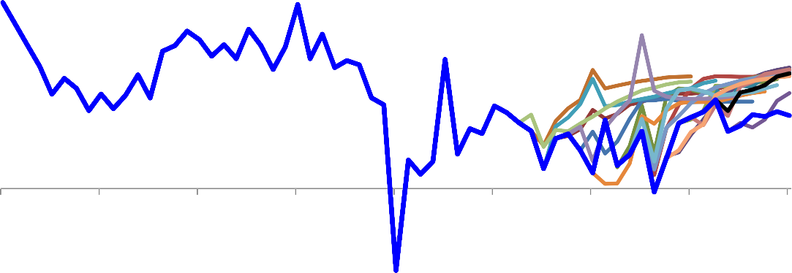

6

5

4

3

2

1

0

-1

-2

-3

-4

2001 2003 2005 2007 2009 2011 2013 2015 2017

Data

Sources: ONS and Bank of England calculations.

Notes: ‘Data’ refers to whole economy total pay (average weekly earnings). Other lines show forecast vintages.

## Chart 2: Fitted and ‘inexplicable’ component of wage growth

Four-quarter wage growth, per cent

# 8

6

4

2

0

-2

-4

-6

2010 2012 2014 2016

Residuals Data Explained by equation

Sources: ONS and Bank of England calculations.

Note: ‘Data’ refers to private sector total pay (average weekly earnings).

## Chart 3: UK Phillips curve

Wage inflation (%) 40



35

30

25

20

15

10

5

0

0 2 4 6 8 10 12 14 -5

Unemployment rate (%)

1971-1997 1998-2012 2013-2017

Fitted 1971-1997 Fitted 1998-2014 Fitted 2013-2017

Sources: ONS and Bank of England calculations.

Notes: Wage inflation refers to annual whole economy total pay growth.

## Chart 4: US Phillips curve

Wage inflation (%)

10



9

8

7

6

5

4

3

2

1

0

0 2 4 6 8 10 12

Unemployment rate (%)

1971-1982 1983-2011 2012-2017Q1

Fitted 1971-1982 Fitted 1983-2011 Fitted 2012-2017Q1

Sources: Thomson Reuters Datastream.

## Chart 5: UK trade union membership

Per cent of employment

60

50

40

30

20

10

0

1892 1902 1912 1922 1932 1942 1952 1962 1972 1981 1991 2002 2012

Sources: Department for Business, Energy and Industrial Strategy, Thomas and Dimsdale (2017) and Bank of England calculations.

## Chart 6: UK self-employment

Per cent of total employment

16

14

12

10

8

6

4

2

0

1855 1870 1885 1900 1915 1930 1945 1960 1975 1990 2005

Sources: ONS, Thomas and Dimsdale (2017) and Bank of England calculations.

## Chart 7: ‘Zero hours’ contracts

Per cent of employment 3

2.5

2

1.5

1

0.5

0

2000 Q4 2002 Q4 2004 Q4 2006 Q4 2008 Q4 2010 Q4 2012 Q4 2014 Q4 2016 Q4

Sources: ONS Labour Force Survey and Bank of England calculations.

## Chart 8: Frequency of terms in job postings

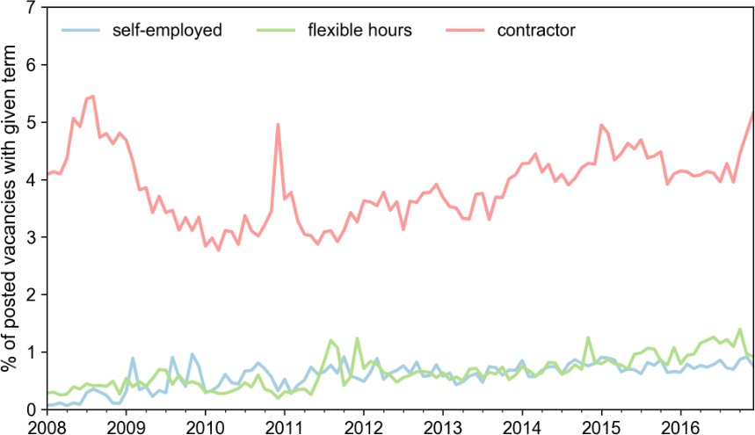

Sources: Reed and Bank of England calculations.

Notes: Chart shows the share of job postings in a data set of job vacancies posted online in the UK which include the terms ‘self-employed’, ‘flexible hours’ and ‘contractor’.

## Chart 9: Distribution of offered wage by occupation, with and without the term ‘self-employment’ in the job advert

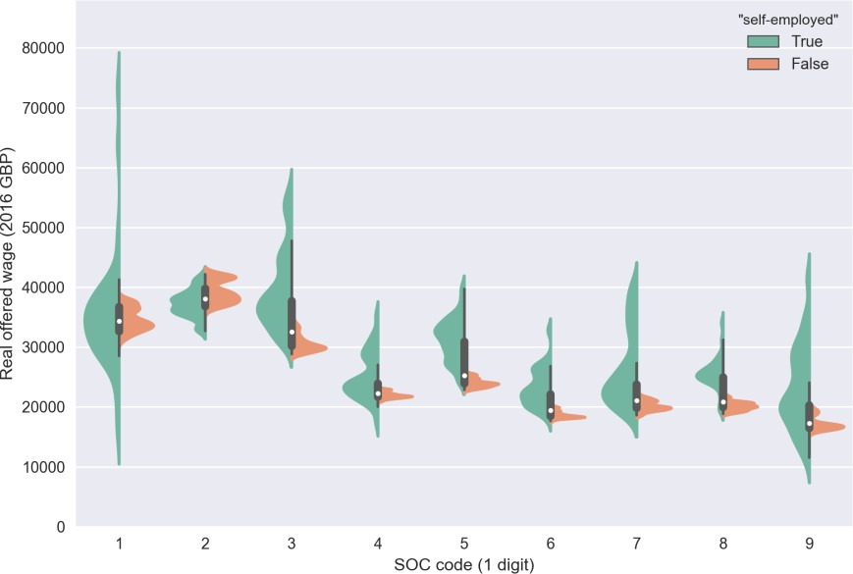

Sources: Reed and Bank of England calculations.

Notes: ‘SOC code’ refers to standard occupational classification code. The area labelled ‘True’ shows the distribution of offered wages for job adverts which include the term ‘self-employment’, and the area labelled ‘False’ shows the distribution for adverts which do not. The data are drawn from a cross-section of online job vacancies. Distributions are constructed using data covering the period 2008-2016.

## Chart 10: Distribution of offered wage by occupation, with and without the term ‘flexible hours’ in the job advert

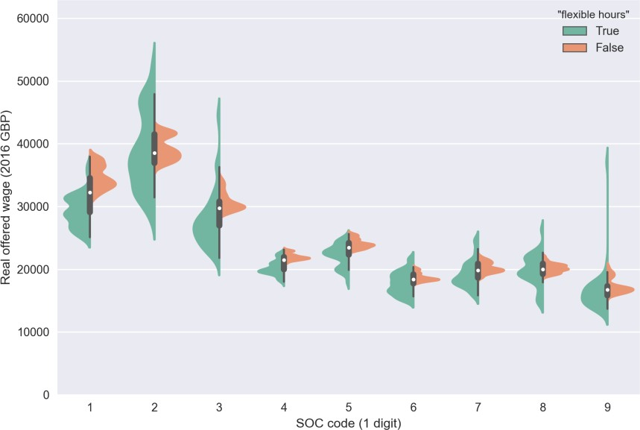

Sources: Reed and Bank of England calculations.

Notes: ‘SOC code’ refers to standard occupational classification code. The area labelled ‘True’ shows distribution of offered wages for job adverts which include the term ‘flexible hours’, and the area labelled ‘False’ shows the distribution for adverts which do not. The data are drawn from a cross-section of online job vacancies. Distributions are constructed using data covering the period 2008-2016.

## Chart 11: Long-run UK Phillips curves

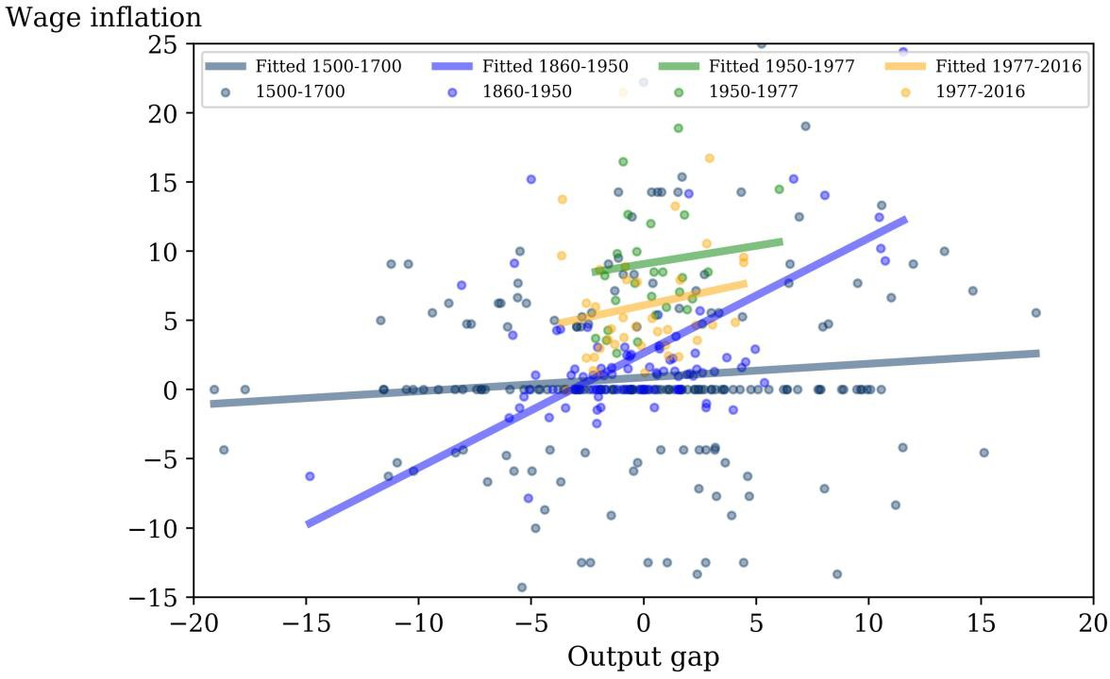

Sources: Thomas and Dimsdale (2017) and Bank of England calculations.

Note: Output gap is estimated using a HP-filter technique. Wage series used is a composite based on English and Great Britain estimates.

## Chart 12: Measures of domestically generated inflation

Percentage change on a year earlier

7

Average of measures

First principal component

6

5

4

3

2

1

0

-1

-2

-3

1997 1999 2001 2003 2005 2007 2009 2011 2013 2015

Sources: ONS and Bank of England calculations.

Notes: Swathe includes core CPI services, inverse import-weighted CPIX, inverse import-weighted core inflation excl. education, unit labour costs, whole economy and private unit wage costs, GDP deflator (unadjusted, as well as versions excl. exports, oil & gas), services GVA deflator, GVA deflator (unadjusted, as well as excl. government) and services PPI.

## Chart 13: World trade in goods and euro-area and US capital goods orders

Percentage change on a year ago

6

5

4

3

2

1

0

-1

2012 2013 2014 2015 2016 2017

World trade in goods Capital goods orders

Sources: CPB Netherlands Bureau for Economic Policy Analysis, European Central Bank, Thomson Reuters Datastream, US Bureau of Labor Statistics, US Census Bureau and Bank of England calculations.

Notes: World trade in goods is a volume measure; capital goods orders is defined as US new orders for non-defence capital goods excluding aircraft, deflated by the private capital equipment producer price index, and euro-area volume of new orders for capital goods, weighted together using 2014 US and euro-area manufacturing value-added data.

Adjusted to match the mean and variance of annual growth in world trade in goods since 2012.

## Chart 14: VIX and media references of uncertainty

Number of references per month Annualised standard deviations

700 70



600 60

500 50

400 40

300 30

200 20

100 10

0 0

2000 2002 2004 2006 2008 2010 2012 2014 2016

VIX (RHS) Media references to uncertainty (LHS)

Sources: Bloomberg, Financial Times, Daily Telegraph, Guardian and Independent.

Note: Media references to uncertainty shows the number of media reports citing uncertainty in relation to a range of political/economic terms across four national broadsheet newspapers (the Financial Times, the Daily Telegraph, the Guardian and the Independent). Last observation for June 2017 is an extrapolation based on observations for the month to date.

## Chart 15: Inflation compensation (5-year, 5-year forward inflation swaps)

Per cent

4

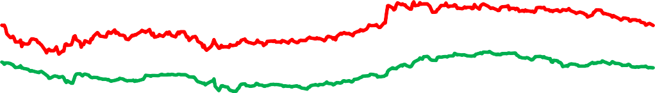

3.5

3

2.5

2

1.5

1

0.5

0

Jan-16 Apr-16 Jul-16 Oct-16 Jan-17 Apr-17

UK US Euro area

Sources: Bloomberg and Bank of England calculations

Notes: UK inflation swaps are based on the retail prices index (RPI), while the US is based on the consumer prices index (CPI) and euro-area series uses the harmonised index of consumer prices (HICP).

## Chart 16: Worldwide Google searches of ‘deflation’ and ‘reflation’ since 2012

Index, 2012-17 peak = 100

2012 2013 2014 2015 2016 2017

Deflation Reflation

100

90

80

70

60

50

40

30

20

10

0

Sources: Google Trends and Bank of England calculations.

## Chart 17: Investment intention indicators

Percentage change on a year ago

20

10

0

-10

-20

-30

2007 2008 2009 2010 2011 2012 2013 2014 2015 2016 2017

BCC CBI Agents EEF ONS

Sources: Bank of England, BCC, CBI/PwC, EEF, ONS and Bank calculations.

Notes:

1. ‘ONS’ is the chained-volume measure of business investment. Data are to 2017 Q1 and adjust for the transfer of the nuclear reactors form the public corporation sector to central government in 2005 Q2.
2. EEF and CBI measures are net percentage balances of respondents reporting that they have increased planned investment in plant and machinery for the next twelve months. EEF measure corresponds to the manufacturing sector and CBI sectoral surveys are weighted together using shares in real business investment.
3. BCC measure is the net percentage balance of respondents reporting that they have increased planned investment in plant and machinery. Sectoral surveys are weighted together using shares in real business investment. Data are non-seasonally adjusted.
4. Agents measure shows companies’ intended changes in investment over the next twelve months, with sectoral surveys weighted together using shares in real business investment. Last observation in the quarter.

## Chart 18: Sensitivity of UK 3-year government spot interest rates to economic surprises

Rolling 1-year sensitivity

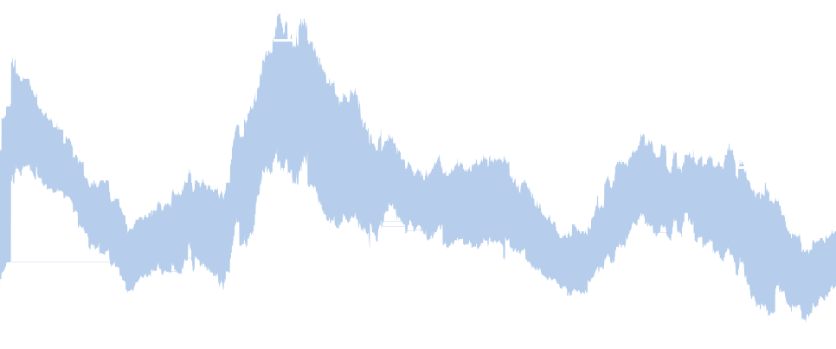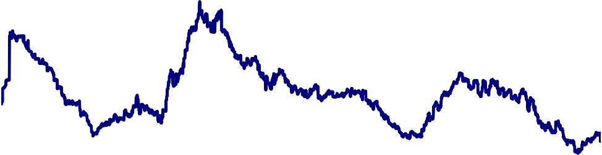

95% CI

UK 3-year

2004 2007 2010 2013 2016

0.8

0.7

0.6

0.5

0.4

0.3

0.2

0.1

0.0

-0.1

Source: Bloomberg and Bank of England calculations.

Notes: The chart shows the rolling 12 month beta coefficient of a regression of the UK Economic Surprise Index (ESI) on daily changes of UK 3-year interest rates, with a 95% confidence interval. The ESI is calculated as the weighted sum of data surprises across the UK, US, euro area, Japan and China. The data series included in the ESI, and the estimated weights are based on their historical relationship with daily changes in UK interest rates. The axis shows the impact of a 1 standard deviation data surprise on UK 3-year interest rates. The dashed line shows the 2004-2017 average for the beta coefficient.

## References

Abel, W, Burnham, R and Corder, M (2016), ‘Wages, productivity and the composition of the UK workforce’, *Bank of England Quarterly Bulletin*, Q1, pp. 12-22.

Bank of England (2016), ‘Factors affecting the prospects for long-term supply following the EU referendum’, *Bank of England Inflation Report*, August, pp. 29.

Blanchflower, D (2007), ‘Entrepreneurship in the UK’, speech at the Max Planck Summer Institute on Entrepreneurship Research.

Blanchflower, D, Costa, R and Machin, S (2017), ‘The Return of Falling Real Wages’, *CEP Real Wages Update*, London School of Economics Centre for Economic Performance.

Bradley, J (2016), ‘Self-employment in an equilibrium model of the labor market’, *IZA Journal of Labor Economics*, 5:6. Bryson, A (2014), ‘Union wage effects’, article for *IZA World of Labor*.

Chapman, B (2017), ‘UK must combat unfulfilling jobs and commit to ‘good work’ economy, says Matthew Taylor’, article in *The Independent*.

Evans, C (2011), ‘A risk management approach to monetary policy’, speech delivered at the Ball State University Center for Business and Economic Research Outlook Luncheon.

Gardiner, L (2016), ‘A-typical year?’, article for the *Resolution Foundation*.

Gregg, P, Fernandez Salgado, M and Machin, S (2014), ‘Real Wages and Unemployment in the Big Squeeze’, *Economic Journal*, 124 (576), pp. 408-432.

Hamilton, B,H (2000), ‘Does Entrepreneurship Pay? An Empirical Analysis of the Returns of Self-Employment’, *Journal of Political Economy*, Vol. 108, No. 3, pp. 604-631.

Hook, L (2015), ‘Year in a word: Gig economy’, article in the *Financial Times*.

Hudson-Sharp, N and Runge, J (2017), ‘International trends in insecure Work’, Report for the *TUC*.

IMF (2017), ‘Understanding the Downward Trend in Labor Income Shares’, *IMF World Economic Outlook*, April 2017. Lewis, HG (1986), *Union Relative Wage Effects: A Survey,* University of Chicago Press.

Monetary Policy Committee (2017), ‘Monetary Policy Summary and minutes of the Monetary Policy Committee meeting ending on 14 June 2017’, *Bank of England*.

OECD (2017), ‘OECD Employment Outlook 2017’, *OECD Publishing*, Paris.

Solow, R (2015), ‘The Future Of Work: Why Wages Aren’t Keeping Up’, article in the *Pacific Standard*.

Thomas, R and Dimsdale, N (2017), ‘A millennium of macroeconomic data’, Bank of England OBRA dataset, <http://www.bankofengland.co.uk/research/Pages/datasets/default.aspx>